English Title <14p, Arial>

o Author1, Affiliation, Address, E-mail: <10pt, Times> ("o" for speaker)
Author2, Affiliation, Address, E-mail:

Abstract must be 100 – 150 words using 9pt Times font. This is a simple example of how to prepare the paper for CFD38. The headings should appear as above. The instruction is written in the main body. Abstract must be 100 – 150 words using 9pt Times font. This is a simple example of how to prepare the paper for CFD38. The headings should appear as above. The instruction is written in the main body.

1. Documents for submission
Paper (PDF, included in symposium proceedings)： A4, double column, maximum 10MB, and maximum 10 pages.

Instruction for making pdf files is as follows. Compose manuscripts including figures and tables by using Word or TeX. Convert the manuscript to a pdf file. Include all the fonts in the pdf file. Make sure that the printed size is A4. Before submission, make sure that there is no typo with multiple PCs.

2. Format
A4 pages should have 20 mm for the top and bottom margins, and 15 mm for the left and right margins. Use 9-point fonts for the text. The text should be in two-column format, except for the title, the authors, and the abstract.

3. Manuscript
- Header Don’t change the header.
- Title Use 14-point fonts of Arial, Helvetica, or cm (bold) font faces. The title should be centered. The first letters of the main words should be capitalized.
- Authors Use 10-point fonts of Times, Times New Roman or cm font faces. The authors are followed by their affiliation, postal address, and E-mail address (if possible).
- Abstract Necessary only for a paper. Use 9-point fonts of Times, Times New Roman or cm font faces. Leave 1 line between the authors and the abstract. The abstract should be written in 100 to 150 words. The width of the abstract is 150mm.
- Text Leave 1 line between the abstract and the text.
- Figures and tables Put clear figures at appropriate positions in the manuscript. All the words and the captions of figures and tables should be written in English.
- Bibliography Cite the bibliography like this⁽¹⁾ and put it after the main text.

4. Offprint
No offprint. The papers will be downloaded by participants from the symposium website.

5. How to submit
(1) Please follow the instruction on the symposium website.
(2) If you have any questions, please ask by email:
cfd38@nagare.or.jp

Bibliography
- Arakawa, C. and Taniguchi, N., “How to prepare the paper,” Proc. 17th CFD Symp., 1 (2003), pp. 1-1.

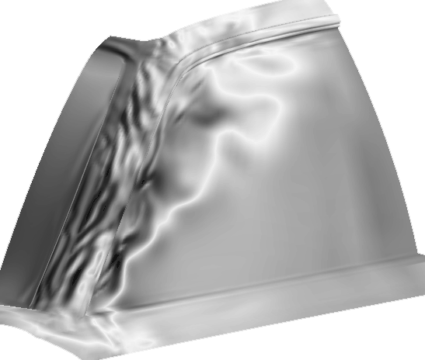
Fig. 1 Sample figure

