English Title <14p, Arial>
○ Author1, Affiliation, Address, E-mail: <10pt, Times> ("○" for speaker)
Author2, Affiliation, Address, E-mail:
The abstract must contain between 100 and 150 words and be written in 10-point Times font. This document provides a basic example of the required paper format for CFD40. The paper title, author names, and affiliations should be presented in the format shown above the abstract. Detailed instructions for preparing the paper, including the required layout and section structure, are provided in the main body of this document. Authors should carefully follow these instructions and ensure that their submissions comply with all formatting requirements, including the specified font, margins, section headings, and maximum paper length. Before submission, authors are also encouraged to review the entire paper for consistency, clarity, grammatical accuracy, and typographical errors.

- Documents for submission
Paper (PDF, included in symposium proceedings): A4, double column, maximum 10MB, and maximum 10 pages.
Instruction for making pdf files is as follows. Compose manuscripts including figures and tables by using Word or TeX. Convert the manuscript to a pdf file. Include all the fonts in the pdf file. Make sure that the printed size is A4. Before submission, make sure that there is no typo with multiple PCs.
- Format
A4 pages should have 20 mm for the top and bottom margins, and 15 mm for the left and right margins. Use 10-point fonts for the text. The text should be in two-column format, except for the title, the authors, and the abstract.
- Manuscript
- Header: Do not change the header.
- Title: Use 14-point fonts of Arial, Helvetica, or cm (bold) font faces. The title should be centered. The first letters of the main words should be capitalized.
- Authors: Use 10-point fonts of Times, Times New Roman or cm font faces. The authors are followed by their affiliation, postal address, and E-mail address (if possible).
- Abstract: Necessary only for a paper. Use 10-point fonts of Times, Times New Roman or cm font faces. Leave 1 line between the authors and the abstract. The abstract should be written in 100 to 150 words. The width of the abstract is 150 mm.
- Text: Leave 1 line between the abstract and the text.
- Figures and tables: Put clear figures at appropriate positions in the manuscript. All the words and the captions of figures and tables should be written in English.
- References: Cite the bibliography like this(1) and put it after the main text.

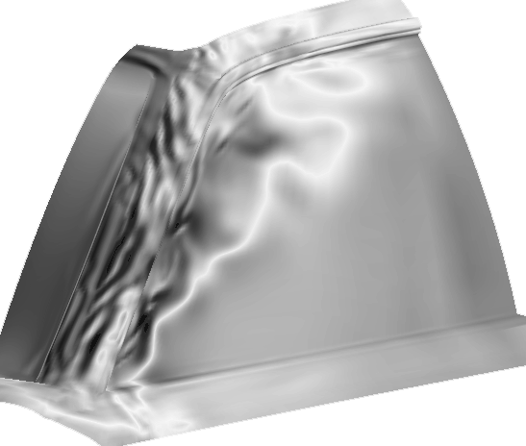
Fig. 1 Sample figure.
- Offprint
No offprint. The papers will be downloaded by participants from the symposium website.
- How to submit
- Please follow the instruction on the symposium website.
- If you have any questions, please ask by email:
cfd40@nagare.or.jp

References
- Arakawa, C. and Taniguchi, N., “How to prepare the paper,” Proc. 17th CFD Symp., 1 (2003), pp. 1-1.

